WHILE STATEMENT

THEORY

The while statement is *drum roll* another flow control, it repeats a piece of code as long as a condition is satisfied. The while statement and the for statement (we’ll see this soon) are also called loops, because they *loop* code. His flow chart would look like this

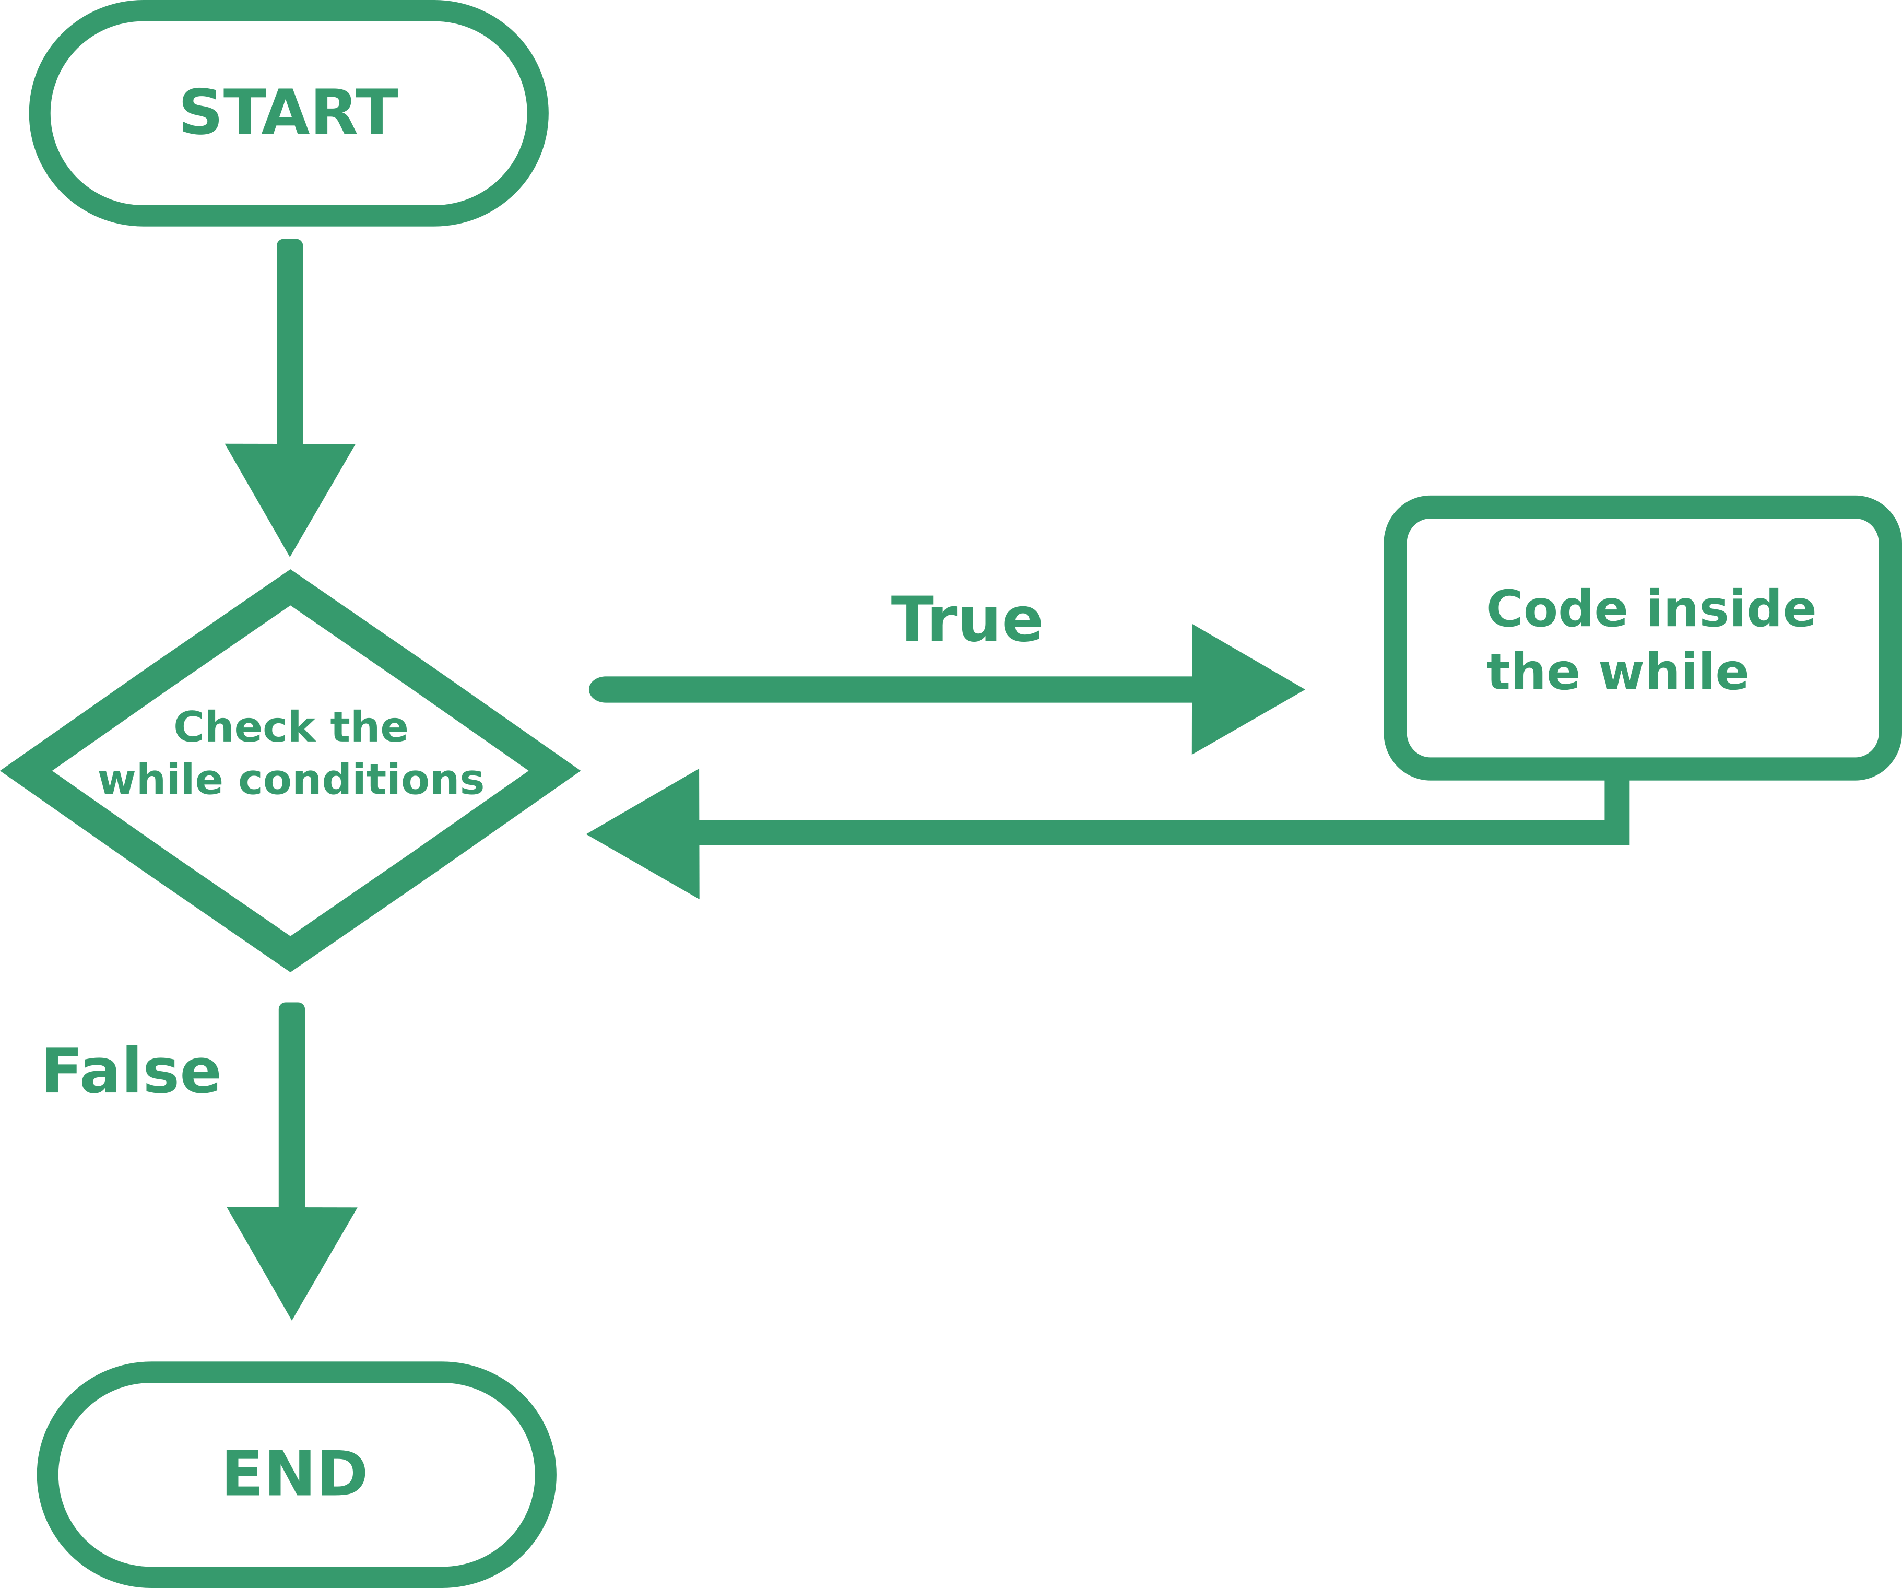

You must be careful with the while statement, because you could create an endless loop.

PRACTICE

The while syntax as you could have guessed is

while (condition){  
 code to execute  
}

If the condition always returns true your program will crash, so don’t do things like this

int x=10;

while (x>0){

Console.WriteLine("Ehi!");

}

And for the while statements it’s all, enjoy!

ASSIGNEMENT

Code a program that given a number as input prints all the numbers from 0 to that number.

TIPS:

* To convert a string into an integer you can use the Int32.Parse(value) method, the input must be a string and the output will be an integer
* Similarly to convert an integer into a string: integer.ToString() where integer is your int variable

BONUS POINT:

* Check if the input is negative and if so respond with an error

SOLUTION:

Console.WriteLine("Write the number here: "); //ask the user for the number

string userinput= Console.ReadLine(); //read what the user wrote

int number= Int32.Parse(userinput); //converts the user input to integer

int x=0; //sets the x to 0

if (number>=0){ //makes sure that the number is greater than 0

while (x<=number){

Console.WriteLine(x.ToString()); //prints x

x++; //adds 1 to x

}

} else{

Console.WriteLine("Error: number smaller than 0"); //prints the error

}

Console.ReadLine(); //we use this command to prevent the windows from closing